Introductions & Conclusions
Introductions and conclusions are important components of any essay. They work to book-end the argument made in the body paragraphs by first explaining what points will be made (in the introduction) and then summarizing what points were made (in the conclusion).

Introductions
An introduction is typically the first paragraph of your paper. The goal of your introduction is to let your reader know what he or she can expect from your paper. While there is no one formula for writing a good introduction, in general, an introduction should do the following:
- Attract the Reader’s Attention
Begin your introduction with a "hook" that grabs your reader's attention and introduces the general topic. Here are some suggestions on how to create a “hook”:
  - State an interesting fact or statistic about your topic
  - Ask a rhetorical question
  - Reveal a common misconception about your topic
  - Set the scene of your story: who, when, where, what, why, how?
  - Share an anecdote (a humorous short story) that captures your topic
- State Your Focused Topic
After your “hook”, write a sentence or two about the specific focus of your paper. What is your paper about? Why is this topic important? This part of the introduction can include background information on your topic that helps to establish its context.
- State your Thesis
Finally, include your thesis statement. The kind of thesis you include depends on the type of paper you are writing, but, in general, your thesis should include:
  - your specific topic
  - your main point about that topic
  - the points of discussion you will include in your paper
Your thesis should be clear, and easy to find. Most often, it is the last sentence of the introduction.

Sample Introduction
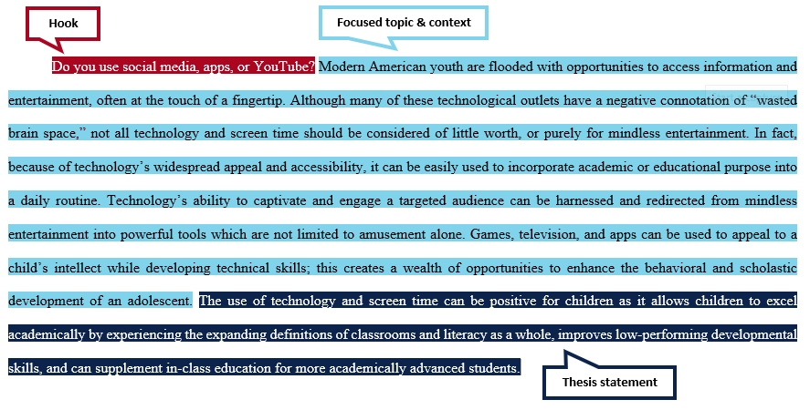

Conclusions
A conclusion works to remind your reader of the main points of your paper and summarizes what you want your reader to “take away” from your discussion. Consider these tips when writing your conclusion:
- Begin with your rephrased thesis statement to remind your reader of the point of your paper.
- Summarize the points you made in your paper and show how they support your argument; tie all the pieces of your paper together.
- Tell your reader what the significance of your argument might be. Why is the discussion important? Do you want your reader to think differently, question something, or perform some action? Make a recommendation of what your reader should "do" with the information you just gave them, or share the importance of the topic.

Sample Conclusion

