11AP
Analyzing Arguments:
From Reading to Writing

Have you ever changed your mind about something? What caused you to re-examine a belief or idea? Most likely, you read or heard someone else’s perspective that challenged you to think about an issue in a different way. It might have been a clear, thoughtful presentation of information, a personal story that tugged at your conscience, a startling statistic, or even a bit of humor or satire that presented a familiar issue in a new and enlightening way. It’s less likely that you were bullied into reconsidering your opinion by a loud voice that belittled your ideas. By carefully and respectfully reading the viewpoints of others and considering a range of ideas on an issue, we develop a clearer understanding of our own beliefs – a necessary foundation to writing effective arguments. In this unit, we’re going to analyze elements of argument as a means of critical thinking and an essential step toward crafting your own argumentative essays.

What is Argument?

Although we’ve been discussing argument in previous chapters, the focus has been primarily on rhetorical appeals and style. We’ll continue examining those elements, but here we take a look at an argument’s claim, evidence, and organization.

Let’s start with some definitions. What is argument? Is it a conflict? A contest between opposing forces to prove the other side wrong? A battle with words? Or is it, rather, a process of reasoned inquiry and rational discourse seeking common ground? If it is the latter, then we engage in argument whenever we explore ideas rationally and think clearly about the world. Yet these days argument is often no more than raised voices interrupting one another, exaggerated assertions without adequate support, and scanty evidence from sources that lack credibility. We might call this “crazed rhetoric,” as political commentator Tom Toles does in the following cartoon.
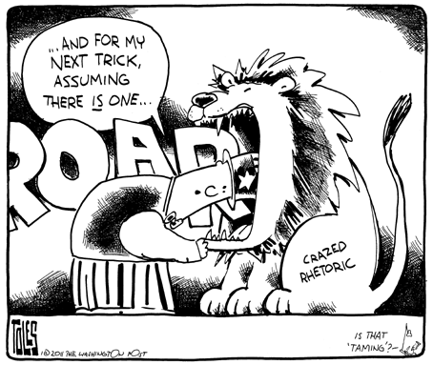
This cartoon appeared on January 16, 2011, a few days after Arizona congresswoman Gabrielle Giffords was the victim of a shooting; six people were killed and another thirteen injured. Many people saw this tragedy as stemming from vitriolic political discourse that included violent language.

1. What is Toles’s argument in this text? We define argument as a persuasive discourse, a coherent and considered movement from a claim to a conclusion.

2. Is Toles’s view exaggerated? Explain.

