8 ½ Character Archetypes You Should Be Writing
Here’s the thing about character archetypes: everybody’s got his own take. Do you run withJoseph Campbell’s gazillion and one Jungian archetypes? How about Dramatica’s double quad of eight archetypes? Or maybe screenwriter Michael Hauge’s simple offering of four main players?
Nothing wrong with running with all of them. The fact that archetypes are both universally applicable and yet endlessly varying provides authors with both structure and flexibility. Character archetypes present important guidelines for creating a well-rounded cast that can provide optimum help for advancing your hero’s journey. But, depending on which approach you take, they can also be either frustratingly vague or claustrophobically limiting.
Today, we’re going to explore my take, which is primarily based on Dramatica’s eight characters. I like this approach because of its logic and comprehensiveness and also because it offers structure without boxing me in.
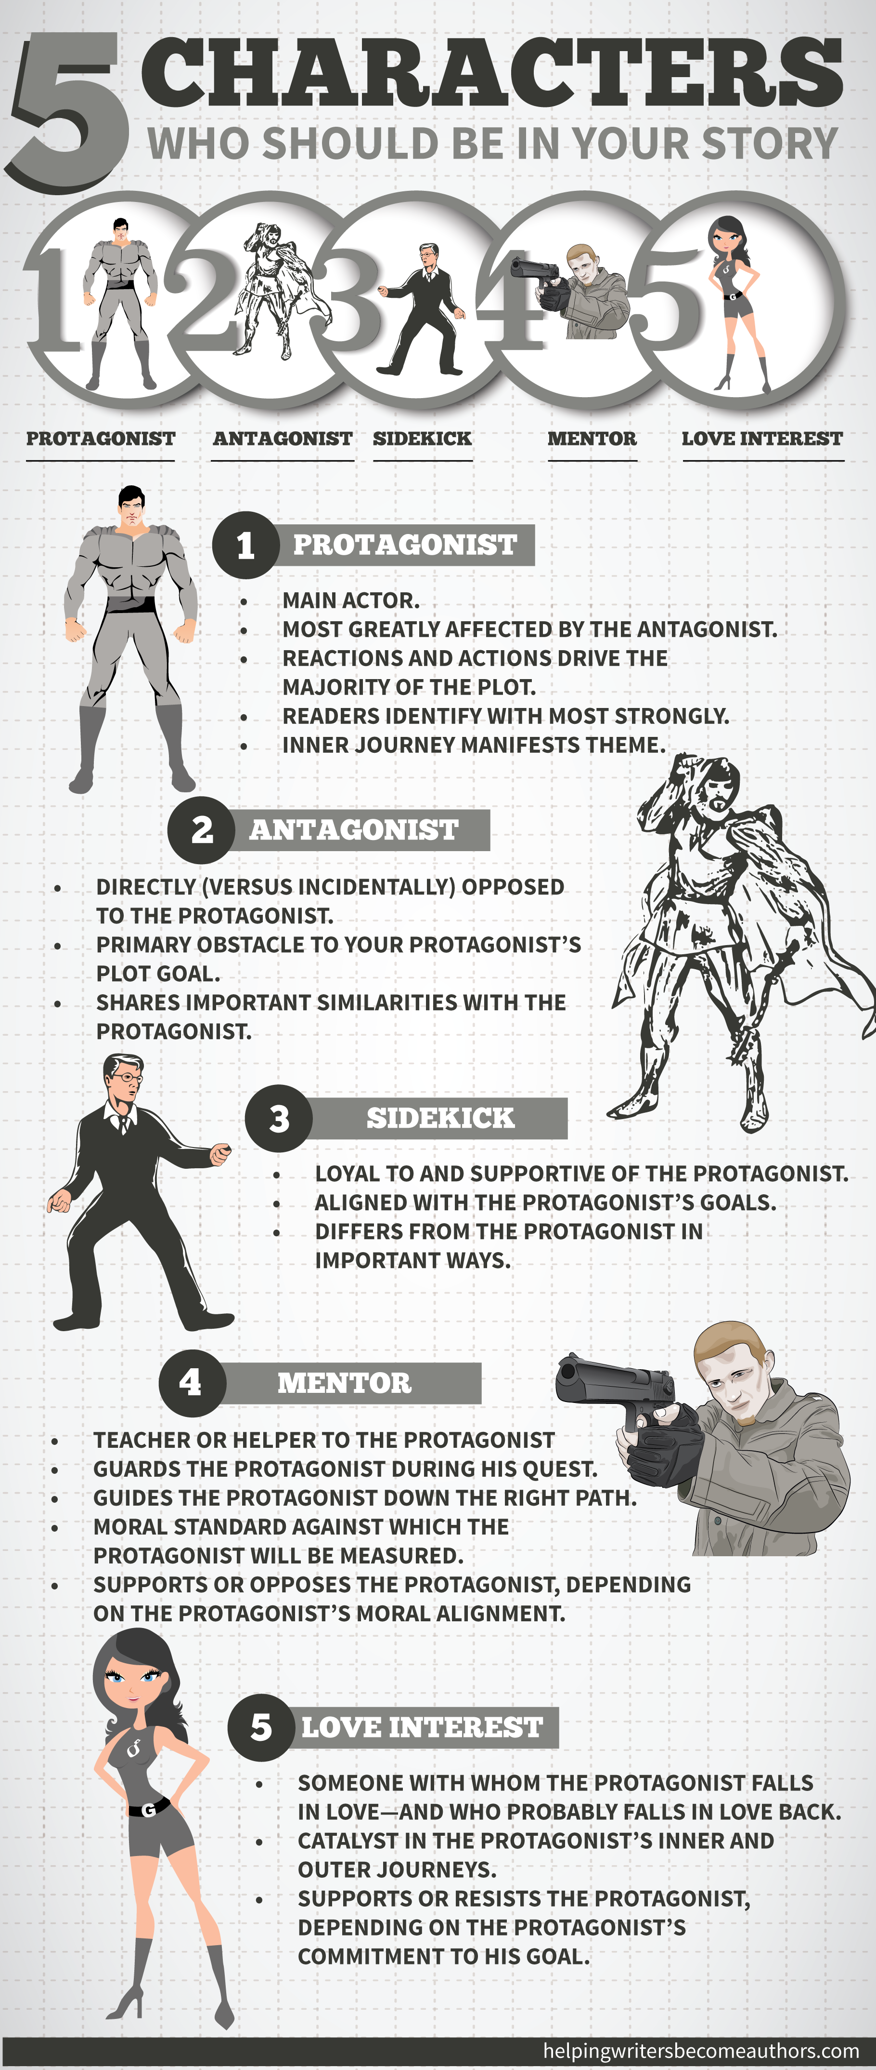

1. Protagonist
This one doesn’t need much explanation. Your Protagonist is the most important person in your story. The story belongs to him. He is:
- The main actor.
- The person most greatly affected by the Antagonist.
- The person whose reactions and actions drive the majority of the plot.
- The person with whom the readers will identify most strongly.
- The person whose inner journey, as influenced by the outer conflict, will be the most obvious manifestation of your story’s theme.

EXAMPLES
Ebenezer Scrooge in A Christmas Carol, Lightning McQueen in Cars, Bruce Wayne in Batman Begins, Mattie Ross in True Grit

2. Antagonist
This one’s also pretty clear. The Antagonist will probably be a character in his own right, or may be an antagonistic force (e.g., weather). The point of his existence, in whatever manifestation, is that he is:
- The main obstacle to your character’s achievement of his main plot goal.
- Directly opposed to your Protagonist (rather than incidentally).
- The person who shares important similarities, whether or good bad, with your Protagonist, in order to highlight and advance areas of Protagonist growth.

EXAMPLES
The Joker in The Dark Knight, President Snow in The Hunger Games, Tai Lung in Kung-Fu Panda, Old Man Potter in It’s a Wonderful Life

3. Sidekick
Sidekicks (or, as Hauge calls them, “reflections”) come in many different forms, everything from a best friend or accomplice to an employee or family member. What’s important is that the Sidekick is:
- Loyal to and supportive of the Protagonist.
- Aligned with the Protagonist’s goals.
- Someone who differs from the Protagonist in important ways, whether good or bad, in order to highlight areas of Protagonist growth.

EXAMPLES
Mater in Cars, Barney Fife in The Andy Griffith Show, Burt the Cop in It’s a Wonderful Life, Nadine Groot in Red River

4. Skeptic
Here’s where Dramatica’s pairing of characters gets interesting. According to this model, every character has his opposite, which allows the author to draw important contrasts and plumb the depths of his theme. Just like the Antagonist is the opposite of the Protagonist, the Skeptic is the opposite of the Sidekick. He is:
- Skeptical (no, really).
- Someone who doubts everything, particularly the Protagonist’s choices.
- Someone who is mostly on the Protagonist’s “side,” but who is pessimistic about the Protagonist’s choices, rather than optimistic.
- A voice of caution (sometimes to the Protagonist’s advantage), more likely to provide reasons why something won’t work than why it will.

EXAMPLES
Sarge in Cars, LaBoeuf in True Grit, Estella in Great Expectations, Hub McCann in Secondhand Lions

5. Guardian
Also popularly known as the Mentor, the Guardian is a classic archetype (think Obi-Wan, Morpheus, and the three ghosts in A Christmas Carol). He is often visualized as a grey-bearded old man, but he can take many forms, everything from a child (Piggy in Lord of the Flies) to an animal (think Pooka in the animated film Anastasia) to a seeming fool (Clarence in It’s a Wonderful Life). He is:
- A teacher or helper.
- Someone who guards the Protagonist during his quest.
- Someone who guides (or sometimes just attempts to guide) the Protagonist down the right path.
- A moral standard against which the Protagonist (and the Antagonist) will be measured.
- Someone who alternately supports or opposes the Protagonist’s ideas, depending upon the Protagonist’s shifting alignment with the story’s moral standard.

EXAMPLES
Alfred Pennyworth in Batman Begins, Shifu in Kung Fu Panda, Garth McCann in Secondhand Lions, Col. Ramsey in The Great Escape

6. Contagonist
This is a term unique to Dramatica’s list of archetypes. As defined by Melanie Anne Phillips and Chris Huntley, the Contagonist “hinders and deludes the Protagonist, tempting it [sic] to take the wrong course or approach.” The Contagonist is:
- Contrasted with the Guardian because he, wittingly or unwittingly, seeks to ultimately hinder rather than help the Protagonist.
- Different from the Antagonist because he is not directly opposed to the Protagonist’s plot goal.
- Someone who may be on the Protagonist’s side in the overall conflict, but who gets in the Protagonist’s way and causes him to consider backing out of the battle against the Antagonist or taking the wrong path to reach his end goal.

EXAMPLES
Doc Hudson in Cars, Col. Phillips in Captain America: The First Avenger, Blanche Ingram in Jane Eyre, Jack Favell in Rebecca

7. Reason
Just as his title suggests, the Reason character is present in the story to provide a voice of logic. He is:
- Someone who is fundamentally logical.
- Someone who makes decisions based on logic, not emotions.
- Someone who acts in logical ways independent of the Protagonist.
- Someone whose logic influences the Protagonist’s choices, for better or worse.

EXAMPLES
C-3PO in Star Wars, Hamm in Toy Story, Inspector Gordon in Batman Begins, Herod in Claudius the God

8. Emotion
If you’ve guessed that the Emotion character is pretty much the opposite of the Reason character, then it’s a gold star for you. The Emotion character is:
- Someone who is fundamentally emotional.
- Someone who makes decisions based on emotions, not logic.
- Someone who may be negatively emotional (e.g., angry) or positively emotional (e.g., compassionate)—or both.
- Someone who acts in emotional ways independent of the Protagonist.
- Someone whose emotion influences the Protagonist’s choices, for better or worse.

EXAMPLES
Mr. Ping in Kung Fu Panda, Cathy in Wuthering Heights, Amelia Sedley in Vanity Fair, Melanie in Gone With the Wind

8 ½. Love Interest
Finally, we come to an archetypal staple not explicit in Dramatica’s presentation. The Love Interest will be found in the vast majority of stories and is not mentioned in Dramatica’s list simply because it will almost always fit into one of the other archetypes as well. However, the Love Interest is worth mentioning independently of the other archetypes both because of its prominence in fiction and because of several important distinctions unique to the role. This character is:
- Someone with whom the Protagonist falls in love—and who probably falls in love back.
- Often a catalyst in either the Protagonist’s inner or outer journey—or both.
- Someone who alternately supports the Protagonist and resists him, depending on which action is necessary to push the Protagonist forward in his personal growth.

EXAMPLES
Miss Sally in Cars, Rachel Dawes in Batman Begins, Rhett Butler in Gone With the Wind, Mr. Rochester in Jane Eyre

Mixing and Matching Character Archetypes
So there you have it! Eight important character archetypes that can power your story and help you create the most fulfilling plot and theme possible.
But wait! There’s more!
Let’s make this whole idea even simpler. As Christopher Vogler puts it in The Writer’s Journey:
…another way of looking at the archetypes [is to see them] not as rigid character roles but as functions performed temporarily by characters to achieve certain effects in a story.
In other words, while you may end up with eight unique characters, you may also decide you can combine your archetypes. Your Love Interest may also be a Skeptic. Your Contagonist may be your Reason character. Your Sidekick may also be your Emotion character. The important thing isn’t that every story presents a unique character for every one of these archetypes. Rather, the important thing is that your story incorporates as many of these characteraspects as possible, so you can bring full-fledged depth and resonance to both your plot and your theme.

