Name Per.
Current Events (online discussion)
Directions
- Find a political current event on the internet that relates to something we study in class (MUST be current within two weeks) using one of these sources

- Politico, Real Clear Politics, NPR, Fox News, USA Today, CNN, MSNBC, New York Times, or The Washington Post

- Create a google doc and title it with the heading of the article you found (source) (share with me just in case)
  - Answer all the prompts on this doc including copying & pasting tweets etc.

- Share with your class…this means everyone, including me
  - Click on paperclip in top right corner and insert the article hyperlink, then pick google drive and find your article in your google drive and attach it
  - Once posted, copy & paste your critical thinking questions as the first comment below your post

You will COVER one current event each quarter (4 total)

Current Event writing prompts
Respond to the article in paragraph form (400-600 words TOTAL)
  - Summarize the article. Do not simply copy a news event. Explain the event in your own words.

  - How does this relate to what we are learning in class?

  - Express your opinion about the information in the article (Do not write in first person)

  - Cover social media on this topic
    - Take snapshots of tweets & try to cover both sides of the story (democrat AND republican responses especially if Trump is involved)

  - Create two question(s) that other students can answer online that will elicit a deeper response than a yes or no (Share through Google docs.)

  - What is the source? Please complete an MLA citation
    - What type of article is this (news article? Editorial / opinion?
    - Was there any bias? If so, please explain.

  - Attach the link of your source so students can go to the article directly if needed

Online Discussion (classmates’ responses)
- Classmates must read your article and must respond to your questions for participation points.
  - Your responses should be a minimum of 50 words and a max of 300 and be rational & educational (3pts max)

Rubric for “Current Events”
Student fills this part out
____Title of Article ____________________________________________________________________________________
____Source (Website attached) __________________________
____Topic matches Unit_______________________

Content “Writing Prompts”
____ Summarized article. Didn’t simply copy a news event. Explained the event in your own words.

____ Related SPECIFICALLY to what we are learning in class?

____ Expressed opinion about information in article.

____ Found social media posts (twitter) from both sides of the aisle (used images placed side by side)

____ Created two deeper thinking question(s) that illicit a response from other classmates

____ Reflected on the source. What type of article is this (news article? Editorial (opinion)? Any bias? If so, explain

Grammar
____ Respond to the article in paragraph form (400-600 words TOTAL__________)

Grade - 20 (MAJOR project grade)
EXAMPLE FORMAT to emulate
Student Name
Student Name

Title: Here's how much D.C. thinks Trump's military parade will cost
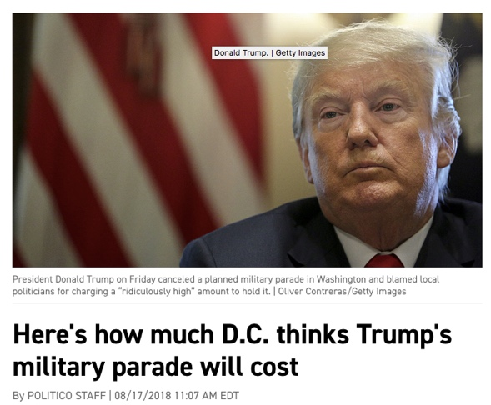
Link: https://www.politico.com/story/2018/08/17/trump-military-parade-cost-783100

Summarize article

President Donald Trump on Friday canceled a planned military parade in Washington and blamed local politicians for charging a “ridiculously high” amount to hold it. This spurred D.C. Mayor Muriel Bowser to respond to the president in a tweet that the parade would have cost more than $20 million but estimates go as high as $92 million

How does this relate to what we are learning in class?
The constitutional powers of the president and his budget (Executive powers & the presidential budget)
This is also connected to be the Constitution unit that outlines presidential powers

Express your opinion about the information in the article.
It is unnecessary to throw money away to simply show the world what the greatest military looks like. America already spends too much on our military and should invest in our education more than we already do. It seems Trump wants to be like dictators and coveted by many

Discuss the social media coverage (Trump’s tweets) on this topic
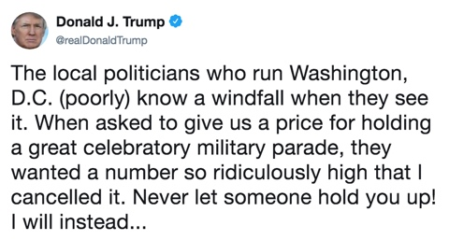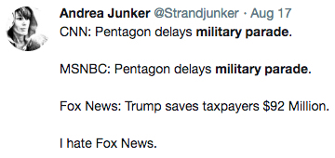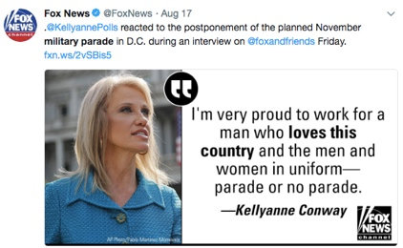

Create a question(s) concerning this current event that other students can answer online that illicit a deeper response than a yes or no

Why was this military parade a good or bad idea in your opinion?

How can a military parade be justified financially when the US has such a large deficit?

What is the source? What type of article is this (news article? Editorial / opinion? Was there any bias? If so, please explain.
This is politico which is usually a moderate new source. It seemed to just report the facts instead of give an opinion on them and allowed me the reader to learn about the facts

