The Silk Road Project
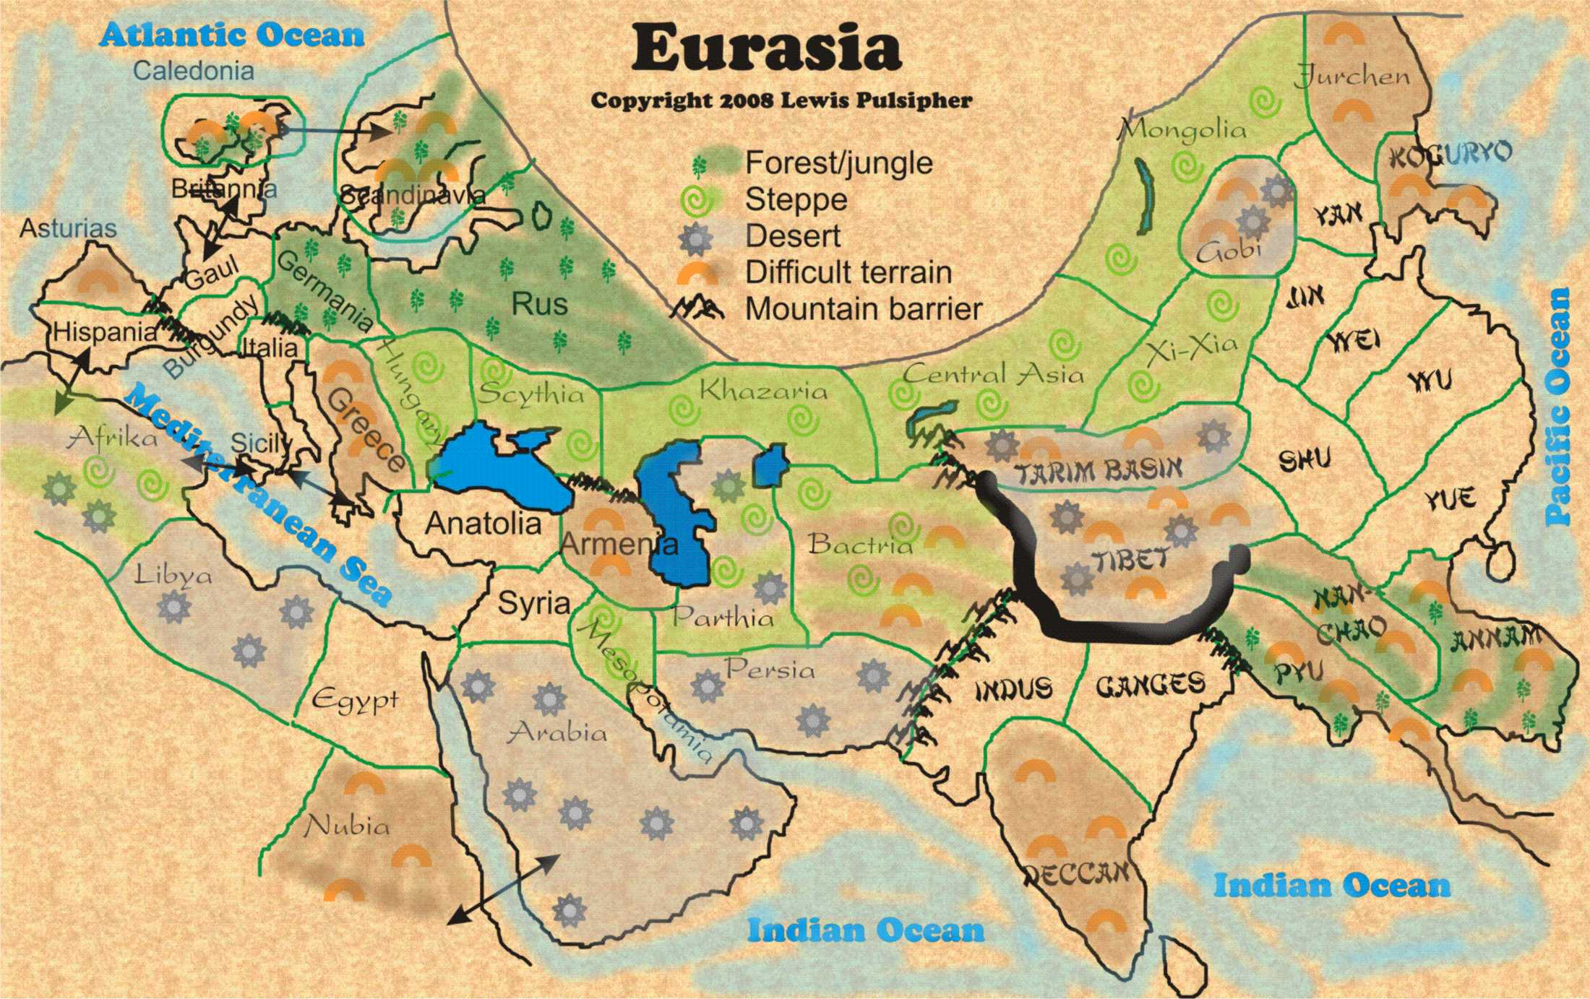
Task 1: The Silk Road
Requirements and Questions:
- Draw the Silk Road on your map and include it in your key. Label key cities.
- Along the Silk Road, DRAW in the luxury goods that were contributed in the place they originated (for example, draw silk in China)
- Answer the following questions as a part of your report:
  - Who conducted trade along the Silk Roads?
  - How did new innovations in transportation technologies and commercial practices facilitate the expansion of trade routes?
  - How did the existing trade routes promote the growth of powerful new trading cities?
  - What were the three most important consequences of trade on the Silk Roads? Label the effects on the map.
  - *How did the Silk Roads change over time? How did they stay the same?
- Resources: A Short History of the Silk Road, The Silk Road Defined, A Short History of the Silk Road, Silk Road Travel Guide,

Task 2: Indian Ocean Trade
- Draw the Indian Ocean Trade Route on your map in a separate color and note it in your key.
- Along the Indian Ocean trade route, draw in the goods that were contributed in the place they originated (For example: Cotton cloth in India).
- Answer the following questions on your map: Required Report Components
  - Who conducted trade on the Indian Ocean? Indian Ocean Trade Game worth reading as it puts the system of trade into perspective.
  - What technologies were innovated to facilitate ocean travel? (Trade technologies)
  - What were the three most important consequences of trade on the Indian Ocean? (Indian Ocean Trade Network)
  - How is Lynda Shaffer’s Southernization a reinterpretation of the importance of Indian Ocean trade?
  - Map One, Map Two, Map Three

Task 3: Trans-Saharan Trade
- Map the Gold/Salt trade and include it in your key. Also include symbols to represent the location of gold and salt in Africa.
- Label the city of Timbuktu
- Answer the following questions in your report:
  - How did Africa's gold/salt trade connect the continent with Europe and Asia?
  - What kind of cultural diffusion occurred as a result of the gold/salt trade?
  - What did the gold/salt trade have to do with the rise of West Africa's three major empires: Ghana, Mali, Songhai?
Task 4: Arab Slave Trade
- Map the Arab Trans-Saharan slave trade ONLY! The Trans-Atlantic slave trade has not yet started! Be sure to include the Arab slave trade on your key.
- Label the Swahili Coast.
- Answer the following questions in your report:
    - Why was there a demand in the Arab world for African slaves? The Role of Islam in African Slavery Part 1 and Part 2
    - How did the Arab slave trade facilitate cultural diffusion?
    - What is the legacy of this slave trade today?

